Lab 1

4.1 enframe

Data.samplingrate= 20000 Hz and window length of 20 milliseconds

So the number of signal in each window is 20kHz \* 20 ms = 400

The shift is 10 ms, the number of overlap signal in one window is 20kHz \* 10 ms = 200

4.2 Pre-emphasis

The lfilter function in scipy.signal:

a[0]\*y[n] = b[0]\*x[n] + b[1]\*x[n-1] + ... + b[M]\*x[n-M] - a[1]\*y[n-1] - ... - a[N]\*y[n-N]

And in our experiment:

y [n] = x[n] − αx[n − 1]

So the filter coefficient :

a is a array with the length of input signal, and a[0] is 1, others are 0.

b is a array with the length of input signal, and b[0] is 1, b[1] is -0.97, others are 0.

4.3 windowing

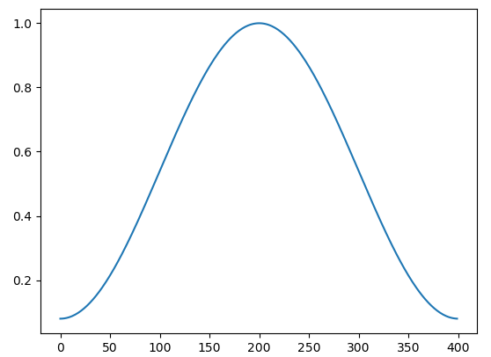

The reason why this windowing should be applied to the frames of speech signal:

1)used as one of many windowing functions for smoothing values.

2)counteract the assumption made by the FFT that the data is infinite and to reduce spectral leakage.